**Batch: A3 Roll. No.: 16010121045**

**Experiment: 11**

**Grade: AA / AB / BB / BC / CC / CD /DD**

|  |
| --- |
| **Title:**  Using virtual labs to understand the data structures |

**Objective:** Use of virtual labs to understand the concepts and theory with examples and verify the same with practice questions.

**Expected Outcome of Experiment:**

|  |  |
| --- | --- |
| **CO** | **Outcome** |
| **CO1** | Explain the different data structures used in problem solving |
| **CO2** | Apply linear and non-linear data structure in application development |
| **CO3** | Demonstrate sorting and searching methods. |

**Websites/books referred:**

**1.**

**2.**

**3.**

Abstract: the virtual lab experiments help in understanding how various data structures work. They also emphasize on some important applications of various data structures and enable students to get familiarized with how certain applications can benefit from the choice of data structures.

Assigned data structure: *(Teacher would assign one of the following to one student)*

1. Stack - <https://ds1-iiith.vlabs.ac.in/exp/stacks-queues/stacks/stackdemo.html>
2. Infix and postfix - https://ds1-iiith.vlabs.ac.in/exp/infix-postfix/evaluation-of-postfix-expressions/postfix_eval.html
3. Queue - <https://ds1-iiith.vlabs.ac.in/exp/stacks-queues/stacks/stackdemo.html>
4. Bubble sort - <https://ds1-iiith.vlabs.ac.in/exp/bubble-sort/bubble-sort/bsexercise.html>
5. Graph DFS - <https://ds1-iiith.vlabs.ac.in/exp/depth-first-search/index.html>
6. Graph BFS - <https://ds1-iiith.vlabs.ac.in/exp/breadth-first-search/index.html>
7. Binary search tree - <https://ds1-iiith.vlabs.ac.in/exp/binary-search-trees/bst-insert/bstInsert.html>
8. Hash tables - <https://ds1-iiith.vlabs.ac.in/exp/hash-tables/quadratic-probing/qp_practice.html>
9. Linked list - https://ds1-iiith.vlabs.ac.in/exp/linked-list/singly-linked-list/sllpractice.html

**Aim / learning objective of the assigned expt:**

In this module, we will be learn about:

* Gain the concept of stacks
* Understand the basic operations of stacks
* Practice the operations of stacks
* Test your conceptual understanding with a short quiz

**Concept and algorithm of the application/activity followed:**

### What are Stacks?

* Imagine a pile of books, with books stacked one over the other. From this pile of books, you can either put another book on top or remove a book from the top.
* The book which is at the bottom of the pile is the last one to be taken out, while the books at the top are removed first. Books can only be added to the top of the pile.
* Let the action of putting a book on the top be called as push and let the action of removing a book be called pop. A type of structure, similar to the example of the pile of books, can be represented as a data structure. Such a data structure is known as a stack.

### Stack Operations and Applications

Just like how we saw in the example of a stack of books, a stack data structure has two types of operations : push and pop. As we can see, a stack is an example of a last in, first out data structure (LIFO). That is, an element that is pushed last into a stack is the first to be popped out. Stacks have many applications. Lets explore a few of them. Reversing a word : Think about how you would reverse a word using a stack. First all the letters are pushed into the stack and then popped out one by one to get the reversed word. This would take linear time O(n). Undoing Changes in a Text Editor : A stack is also commonly used in text editors. Changes that the user makes are pushed into a stack. While undoing, they are popped out.

### Pushing into a Stack

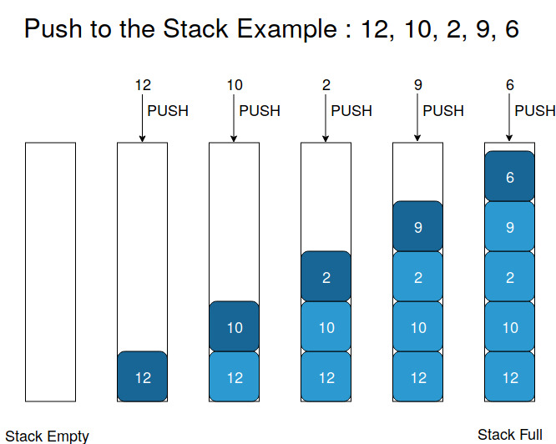

### Popping from a Stack

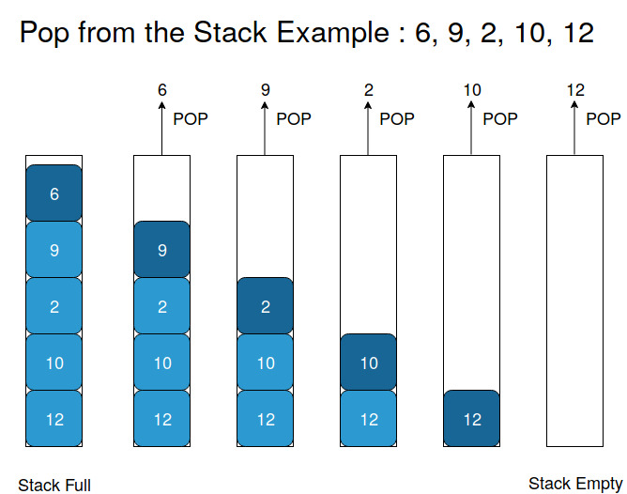

**Demo execution screenshots:** 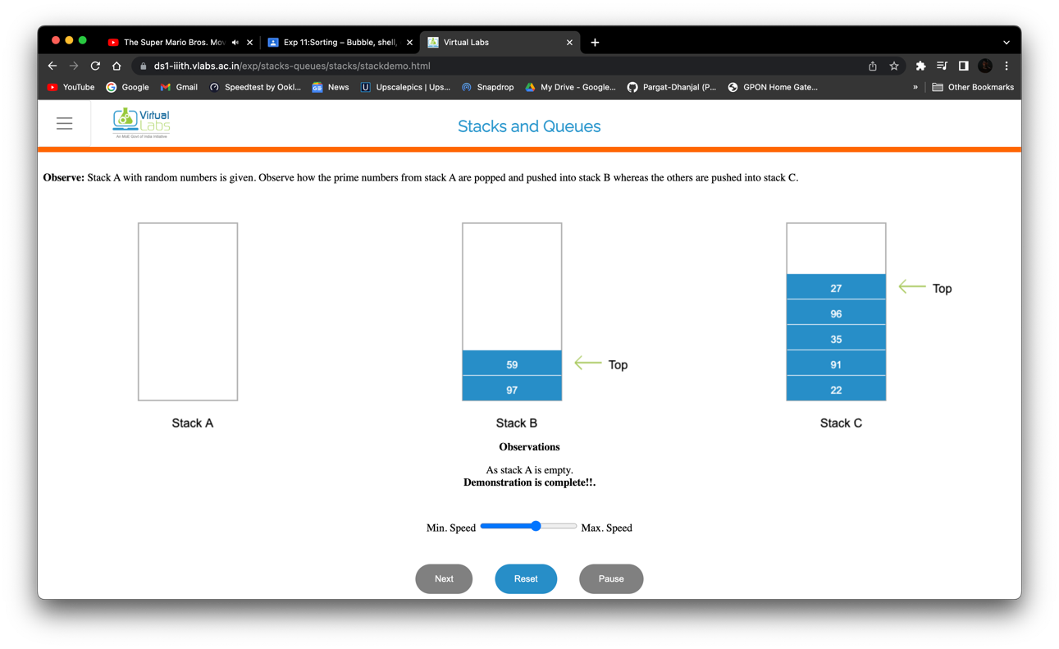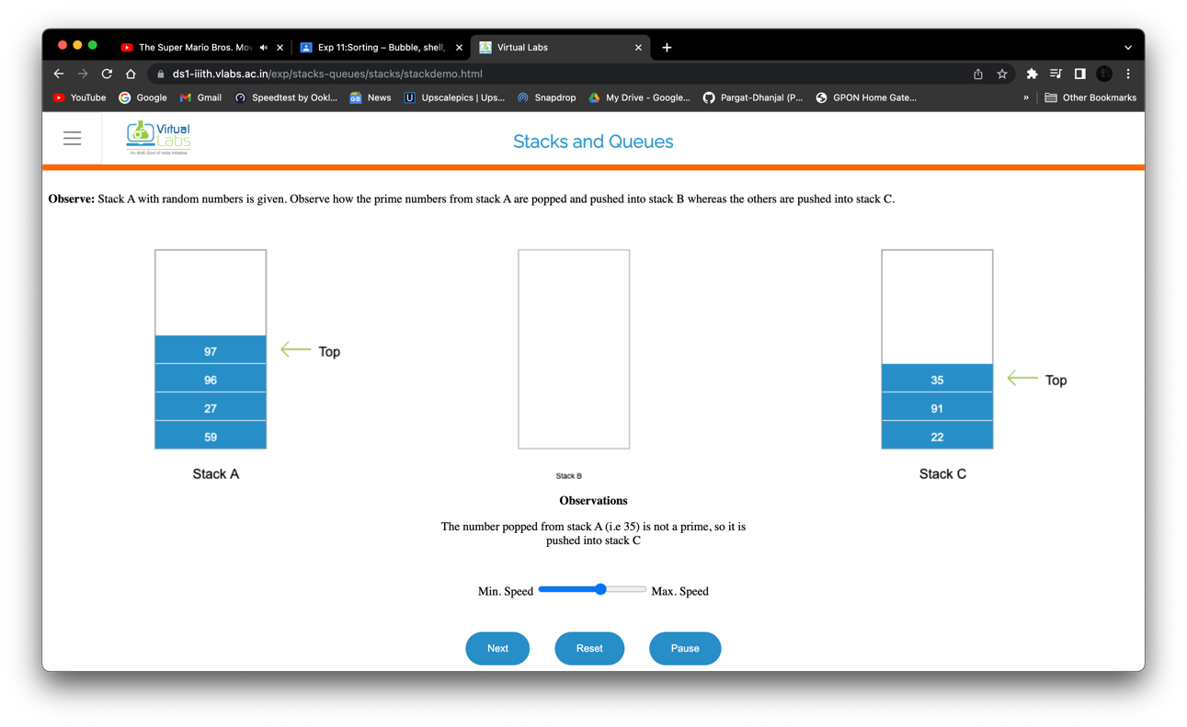

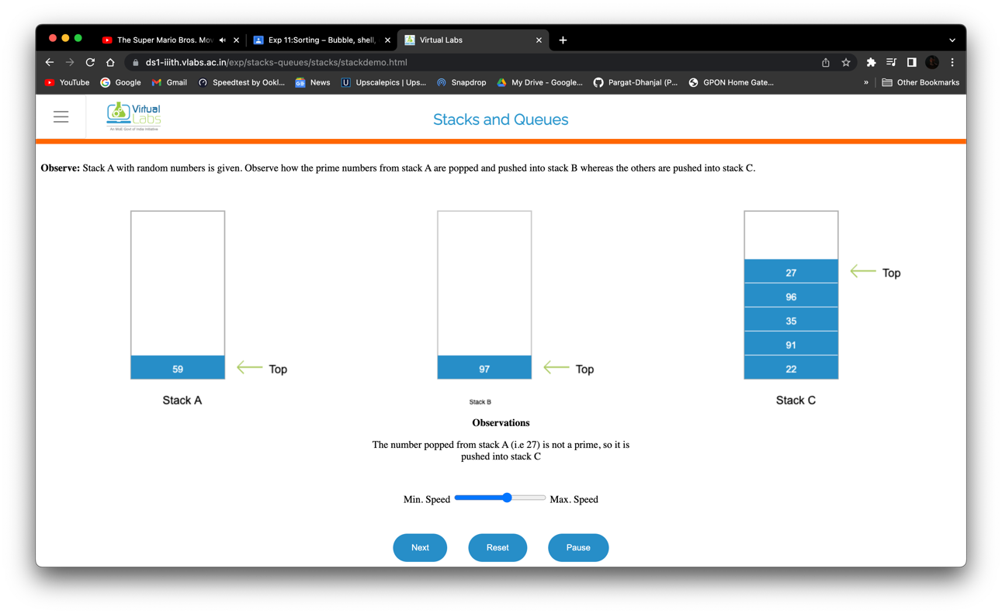

**Practice problem screenshots:** 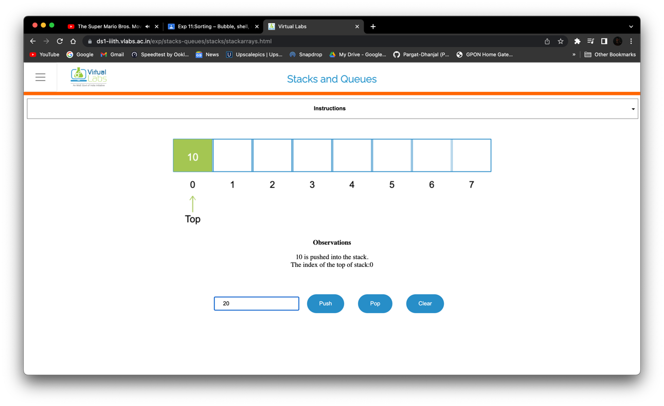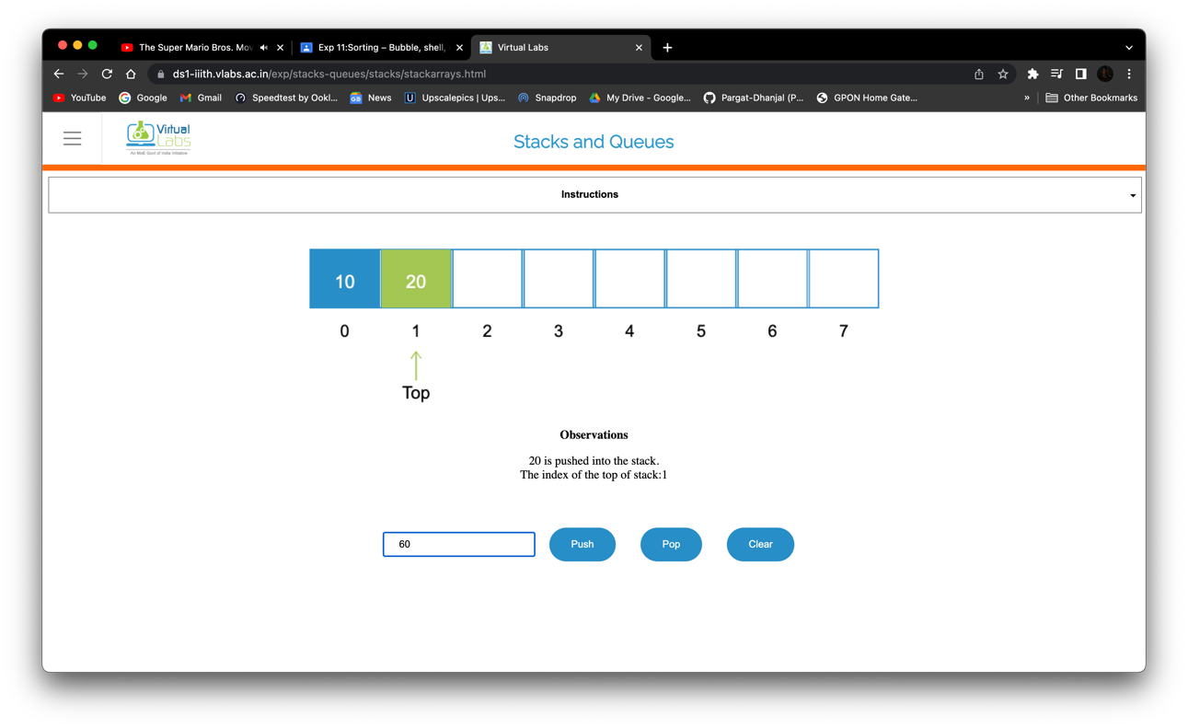

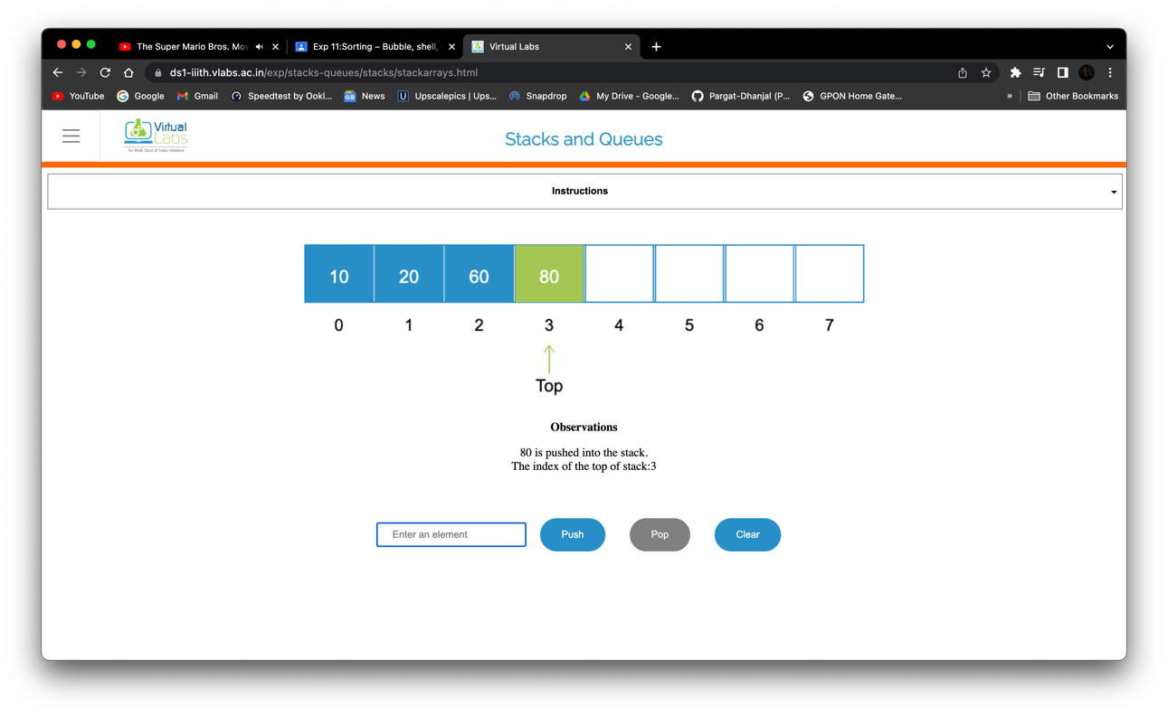

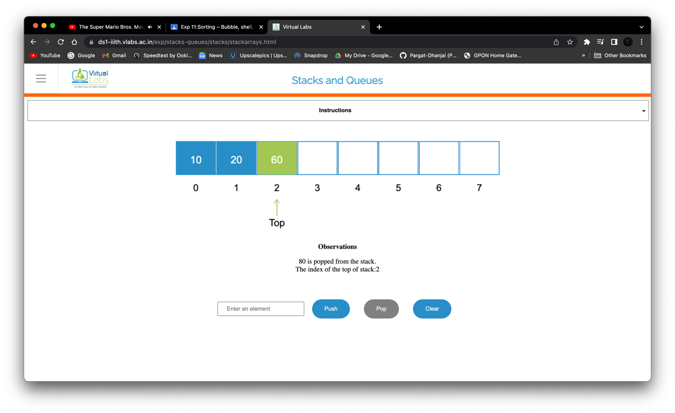

**Quiz screenshots:**

**Conclusion and your take away after performing the virtual lab experiment: -**

Learnt the following:

* Gain the concept of stacks
* Understand the basic operations of stacks
* Practice the operations of stacks